**Que 1 :-**

**1 :- What is software?**

* Software is part of computer that we can’t touch.
* Software is a set of instruction.
* Example :- M.s office, antivirus, windows etc….

**2:- What is software engineering?**

* Software engineering is technique through which we can develop software for computer.
* Software engineering is a process in which user needs are analyzed and software designed based on there needs.
* Software engineer build these software by using designing and programming language.

**Que :- 2**

**Explain types of software**

* There is a 5 types of a software
* Application software
* System software
* Driver software
* Middleware
* Programming software
* **Application software**
* Application software that performs a single task or specific function.
* Example :- word processing s/w

Web browsers

* **System software**
* System software is a group of programs who has design for run a computer hardware and apps.
* System software manage and control computer hardware.
* Example :- windows
* **Driver software**
* Driver software is a type of software program that control a device hardware.
* On any computer, phone
* **Middleware**
* Middleware is mediates between application and system software
* Middleware is work like remote.
* **Programming software**
* Programming software use for write a code.
* Programming software enable developers to develop, write, test, and debug.

**Que 3 :-**

**What is SDLC?**

* Sdlc is a software development life cycle.
* There are 6 phese :-
* Requirement gathering
* Analysis
* Designing
* Coding or implementation
* Testing
* Maintainence
* **Requirement gathering**
* In this phase what a customer actually want in software.
* **Analysis**
* In this phase detailed examination on customer requirement.
* **Designing**
* in this phase create a software design and architecture of the software.
* **Coding or implementation**
* In this phase design implemented in the code.
* **Testing**
* In this phase software thoroughly tested to ensure that meets the actual requirements and working proper or not.
* **Maintenance**
* in this phase include bug fixing, and updates to the software.

**Que 4 :-**

**What is DFD ?**

* Dfd is the data flow diagram.
* It is also gives inputs and outputs.
* Dfd doesn’t have any flow control or decision rules.
* Dfd are commonly used during problem analysis.

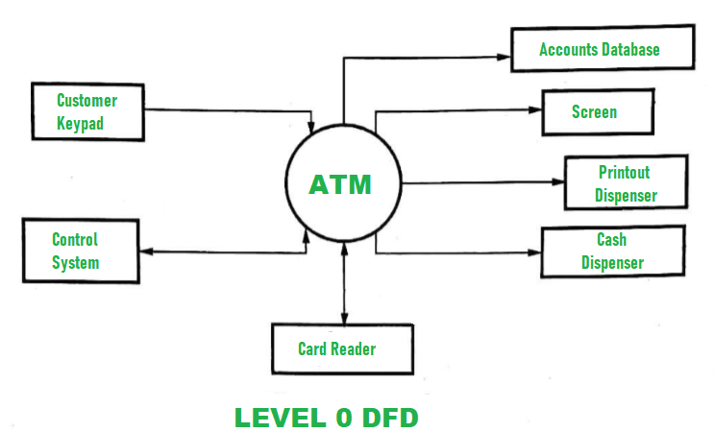

**Que 5 :-**

**What is flow chart?**

* Flowchart is a type of diagram.
* Flowchart represent a workflow.
* It is approach a step by step to solving a task.
* Flowchart has a different type of symbol for process.

**Input number 1,number 2**

**Sum = number 1 + number 2**

**Print sum**

**Que 6 :-**

**What is use case diagram?**

* Use case diagrams is a behaviour of the system and help to capture the requirements of the system.
* Use case diagram describe the high level function and scope of a system.
* Use case diagram also identify the interactions between the system and its actors.